Amazon Web Services

Managing S3 & Glacier

Login to AWS Console

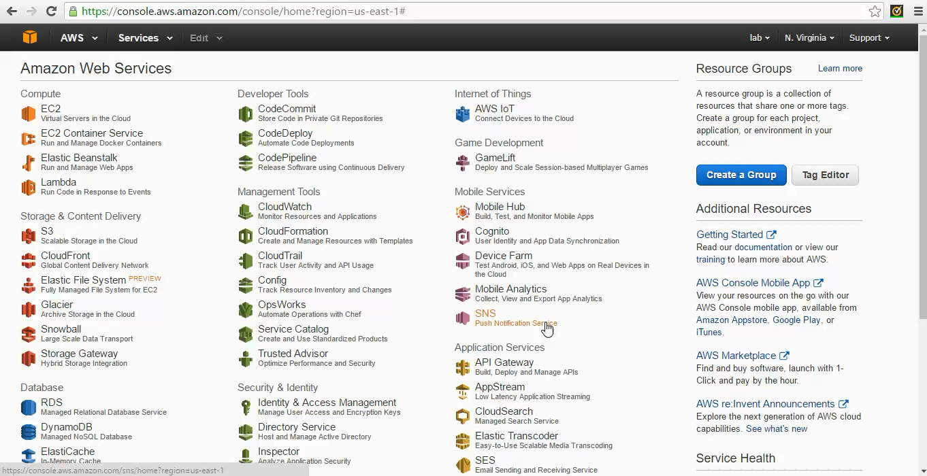

Click on S3

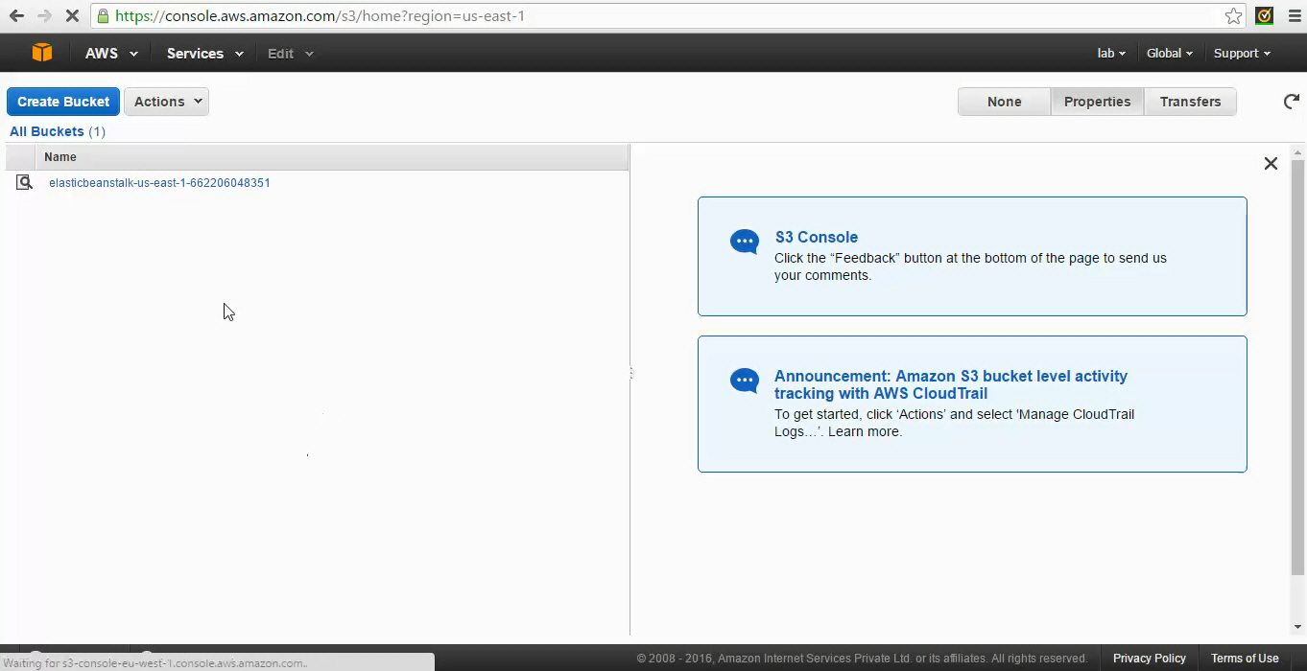

You will see all the available s3 buckers on the s3 dashboard. Click on “Create Bucket” to create a new s3 bucket.

The bucket name should always be globally unique. So give some unique name as shown in the following example.

Ex: demo-<username>- <yyyymmdd> 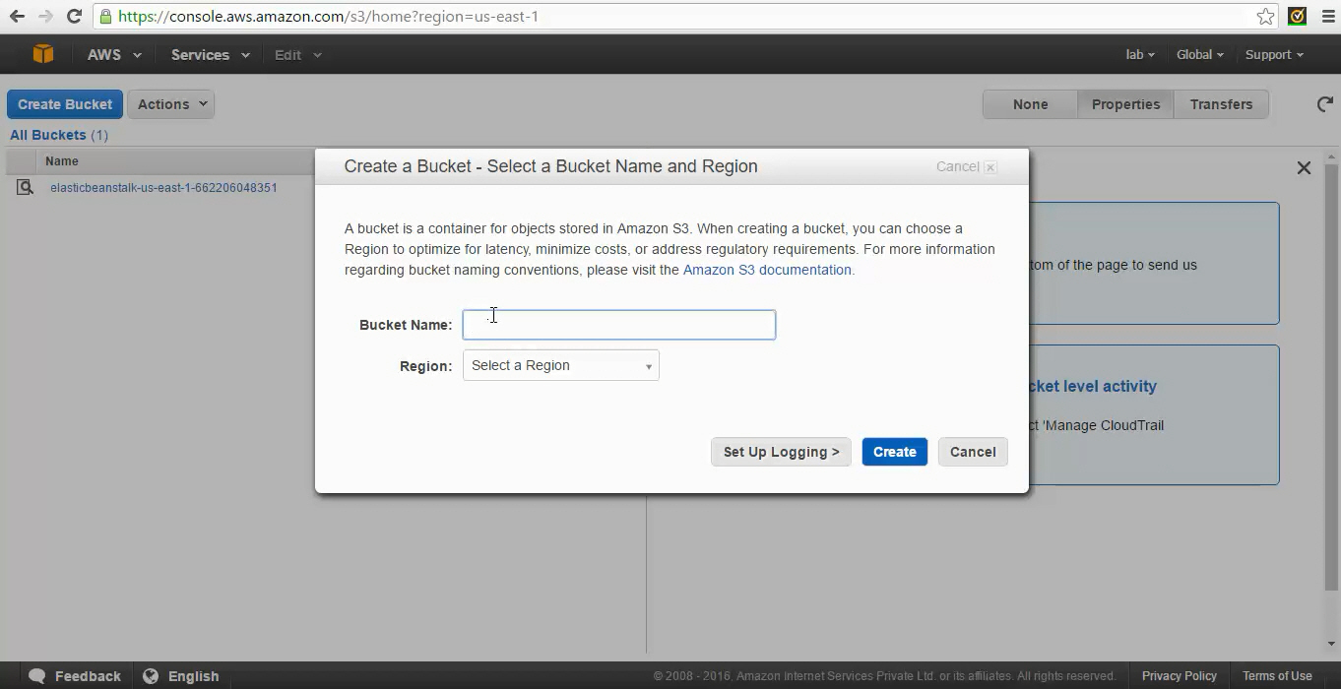

Select the region where you want to create this s3 bucket. By default buckets are created in us-east-1 if you don’t select any region. Click on Create to create s3 bucket.

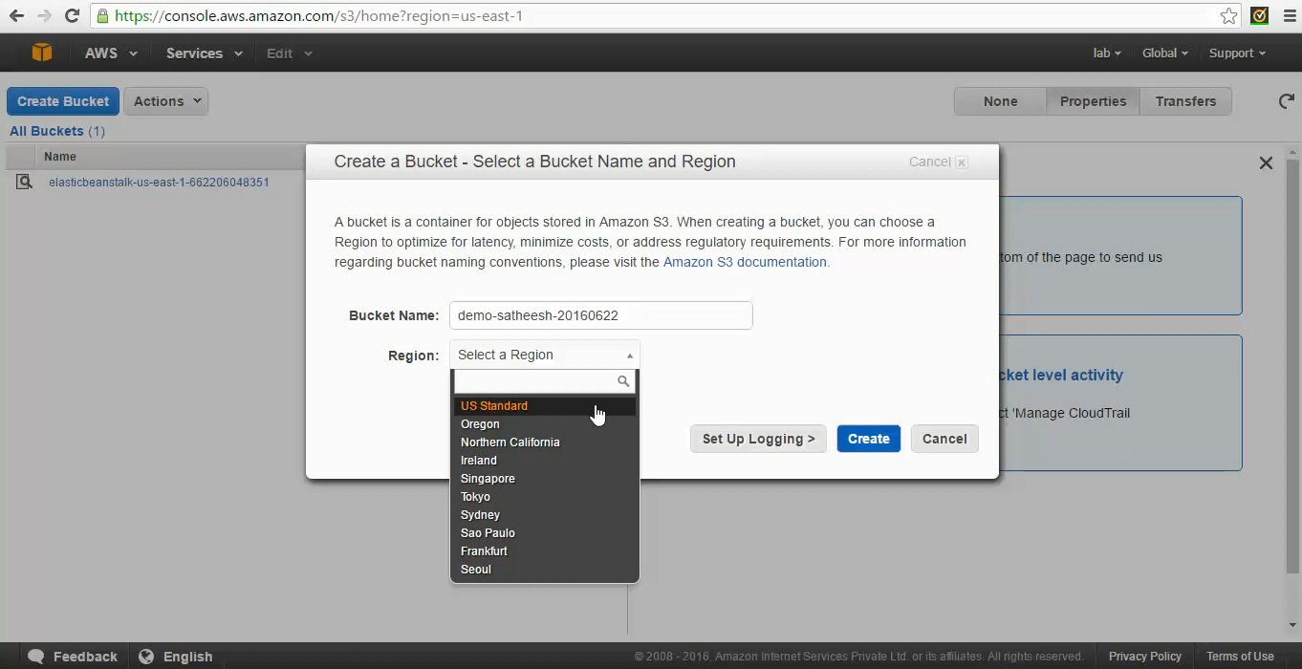

Once the bucket is created click on magnifier icon the left side of the bucket name to see all the properties.

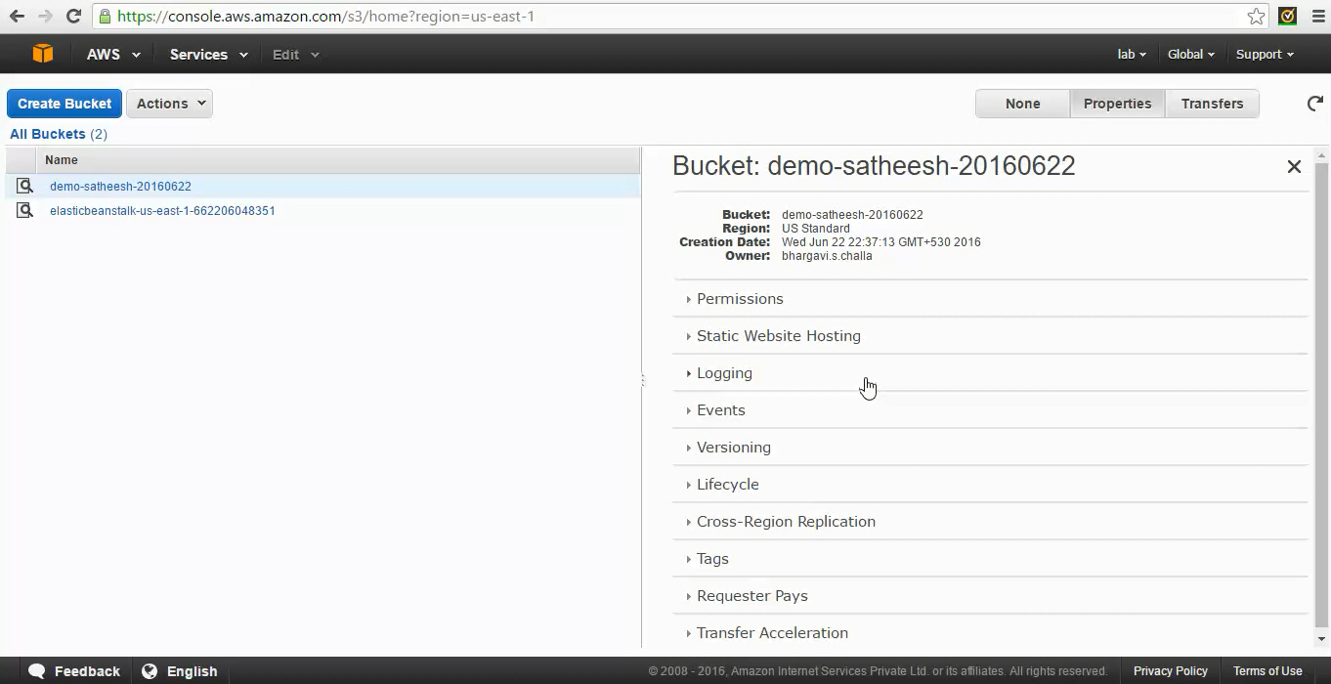

Click on the bucket name to see the content of the bucket.

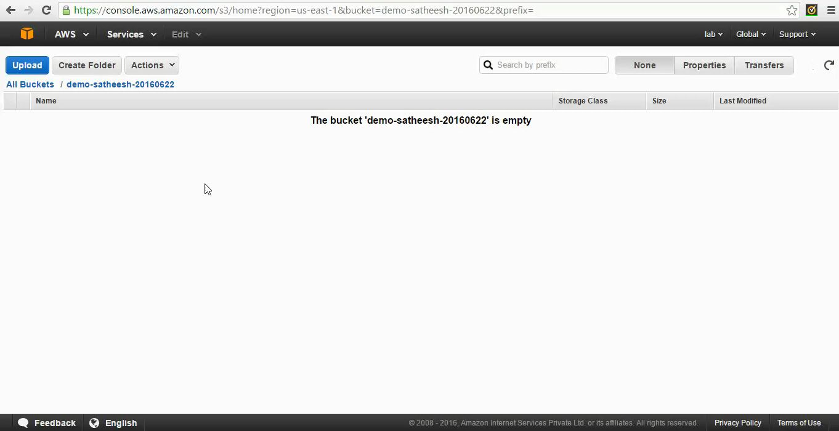

Click on upload and browse the file you want to upload into s3 bucket.

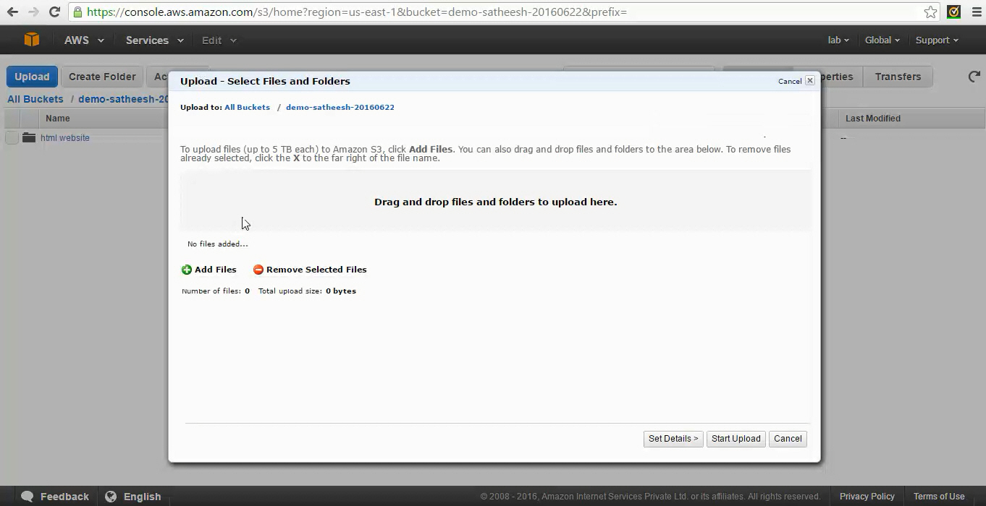

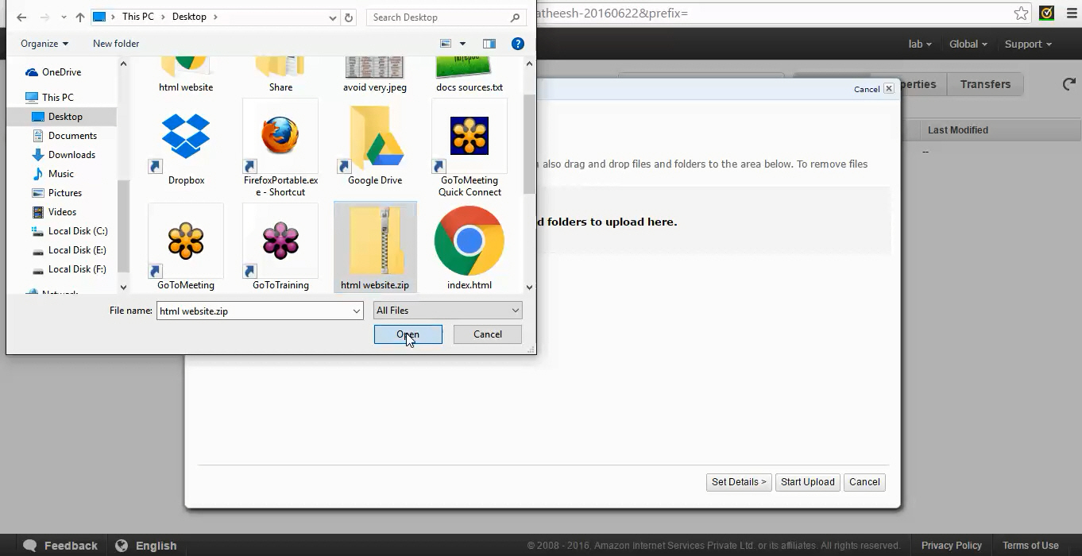

Select the file and click on start upload to upload the files.

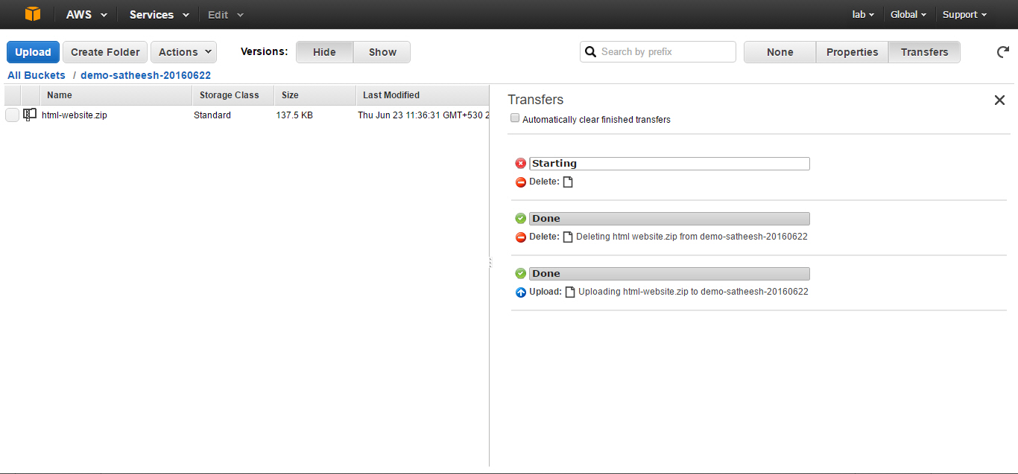

You can see the status of the upload on right panel. If you want to upload multiple files and directories all at the same time click on upload button and drag and drop all the files to pop-up window.

Extract the html-website.zip and upload all the content to the bucket you created.

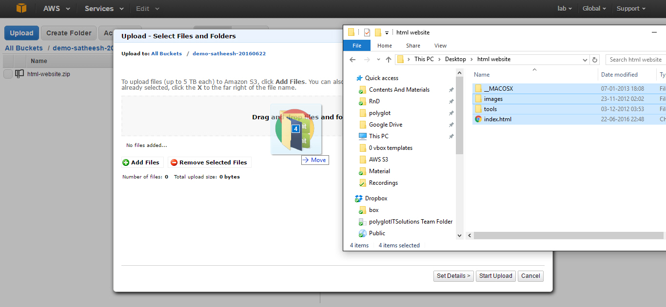

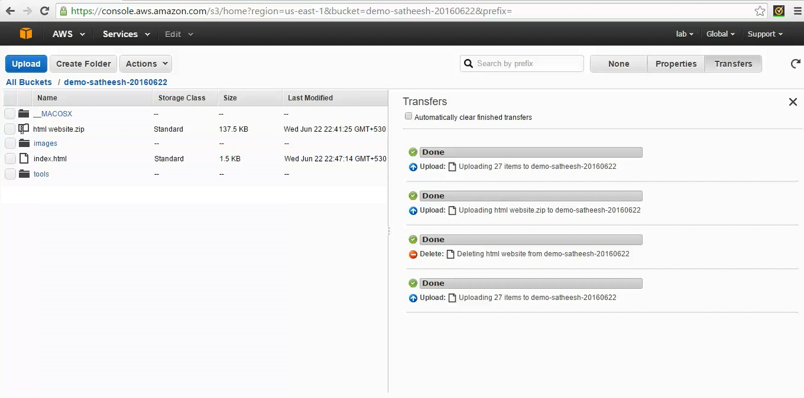

You can build static websites using s3 buckets. To build a new website click on “Static Web Hosting ” option on the bucket properties.



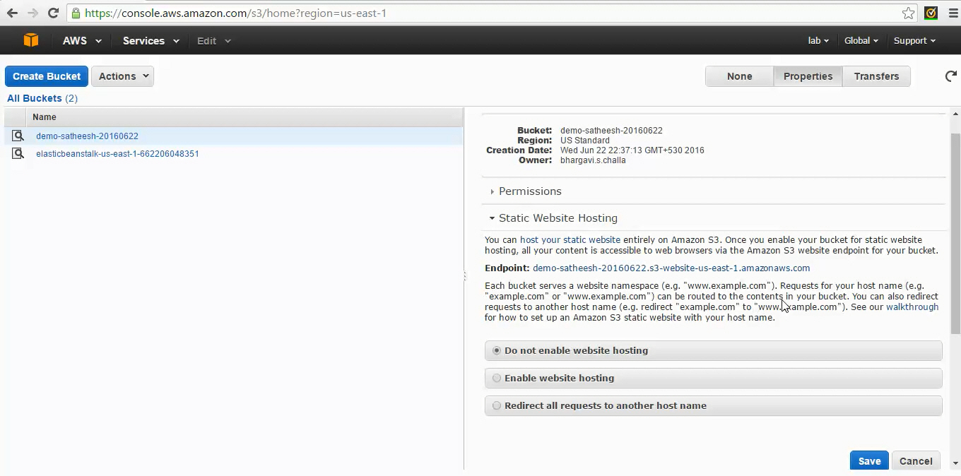

Click on “Enable Website Hosting” radio button and and configure Index Document and Error Document. The index.html file should be available on the s3 bucket in the given location. Index Document is opened by the s3 website when the users access the website URL by default.

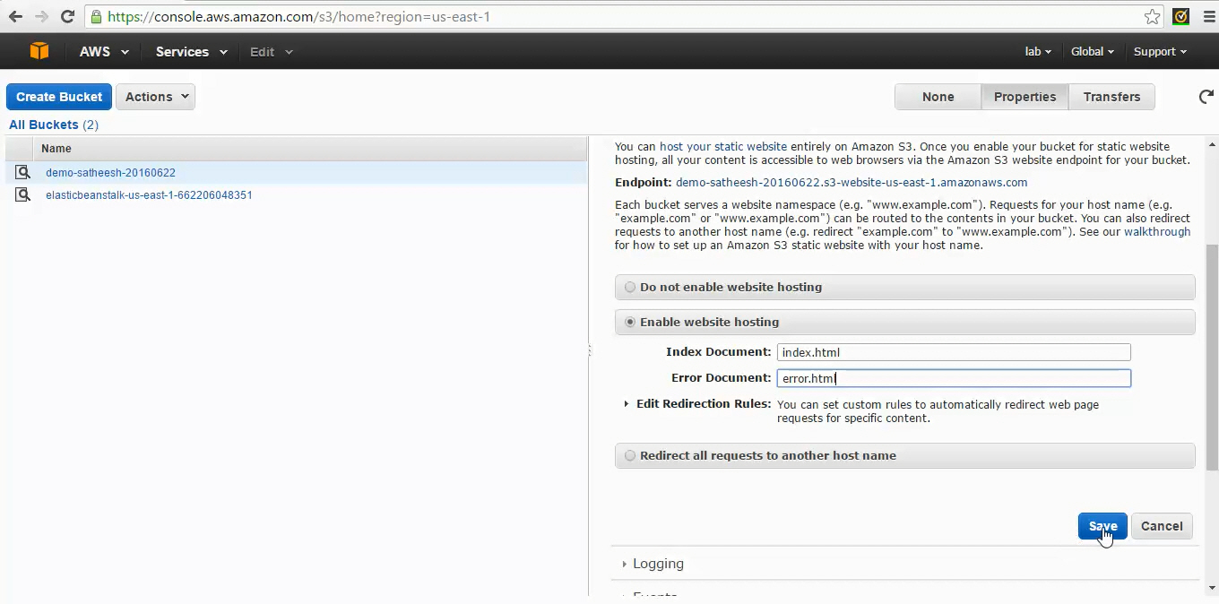

By default s3 content is not accessible to any of the users except the owner. Since we are building a publicly website we need allow the permissions on the s3 bucket to provide read access for anyone. S3 supports policy based access where we can customize the policies to provide access. Click on the “Permissions” on s3 bucket properties to set our policy.

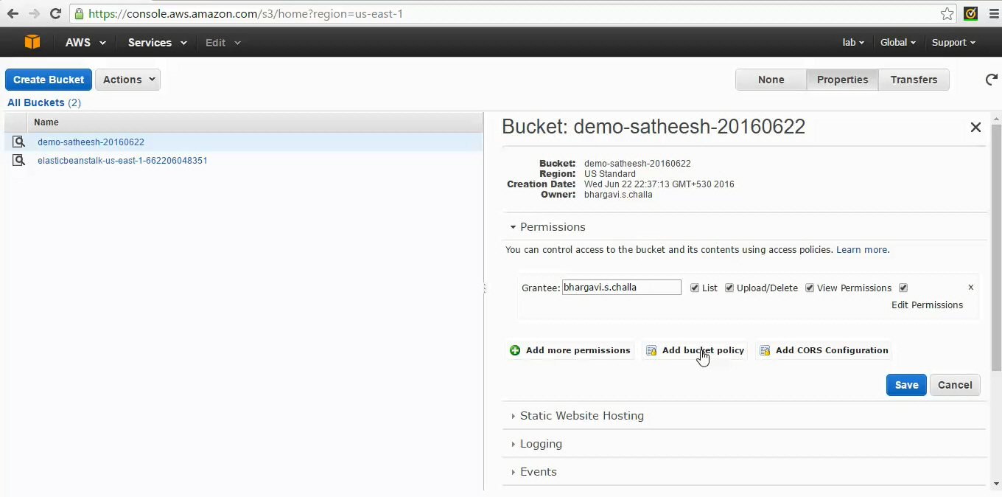

Click on “Add bucket policy”

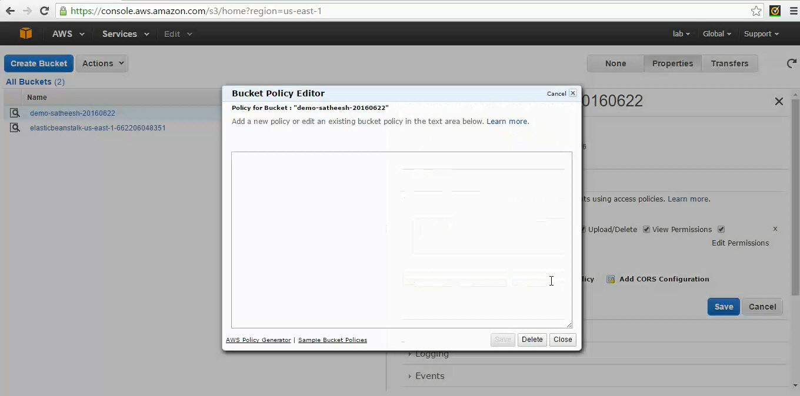

Refer to the sample policy available [here](http://docs.aws.amazon.com/AmazonS3/latest/dev/example-bucket-policies.html#example-bucket-policies-use-case-2). Replace the examplebucket with your bucket name. Put the policy in the policy creation wizard.

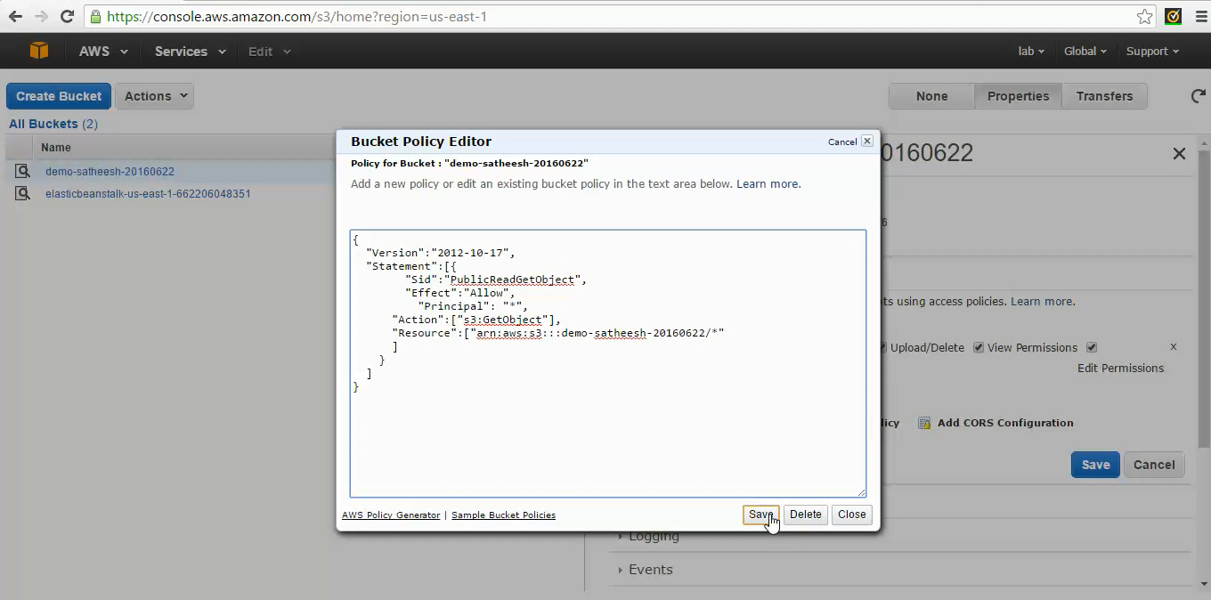

Click on Save.



You can use s3 endpoint displayed in bucket properties to access the website.

If website configuration is successful you would see the following page in the browser.

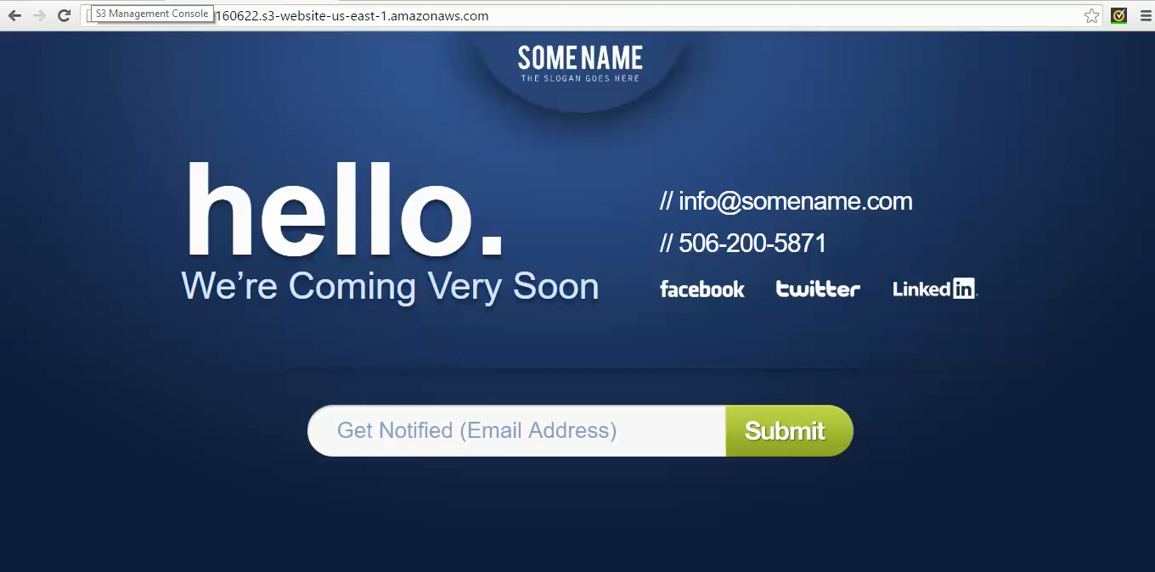

Now let us enable versioning on the bucket created. Click on Versioning in the bucket properties.

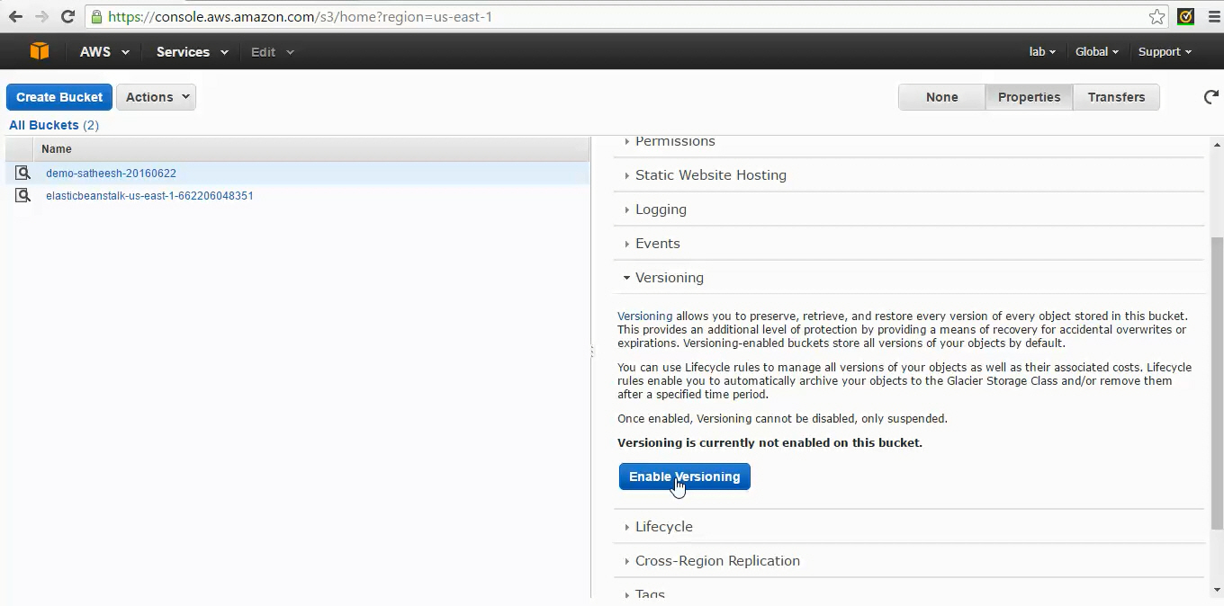

Click on “Enable Versioning”

Once the versioning is enabled on the bucket you see additional options on the bucket attributes.

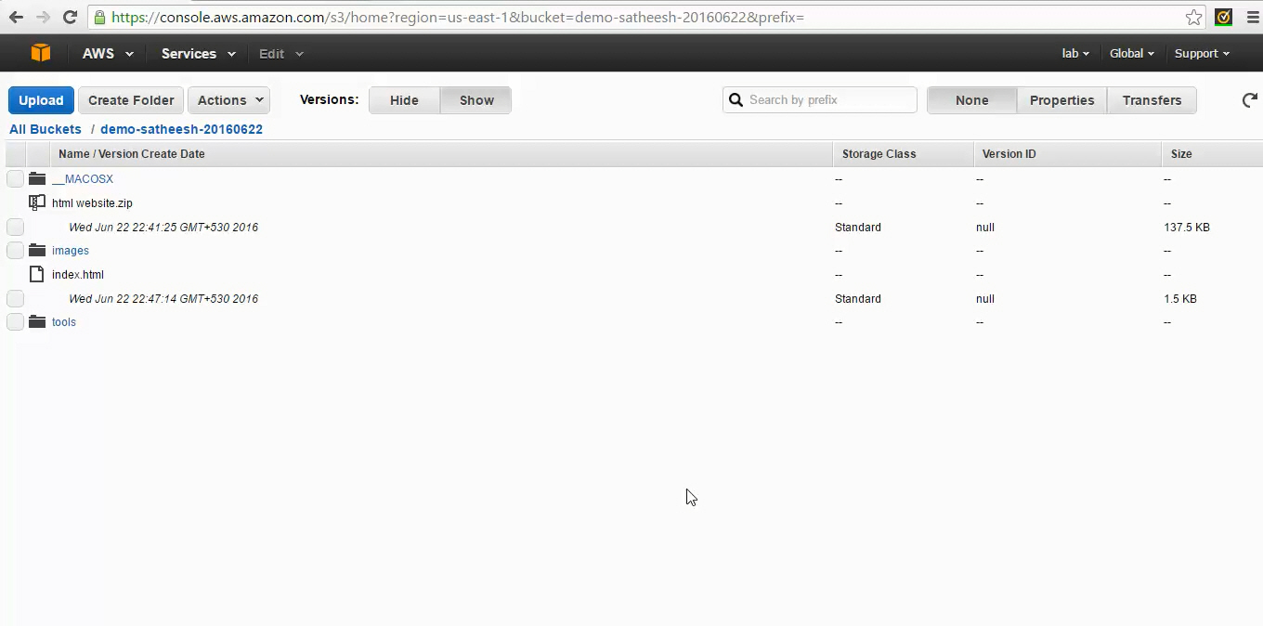

Modify the index.html in html-website on your local system and upload it again to s3 bucket.

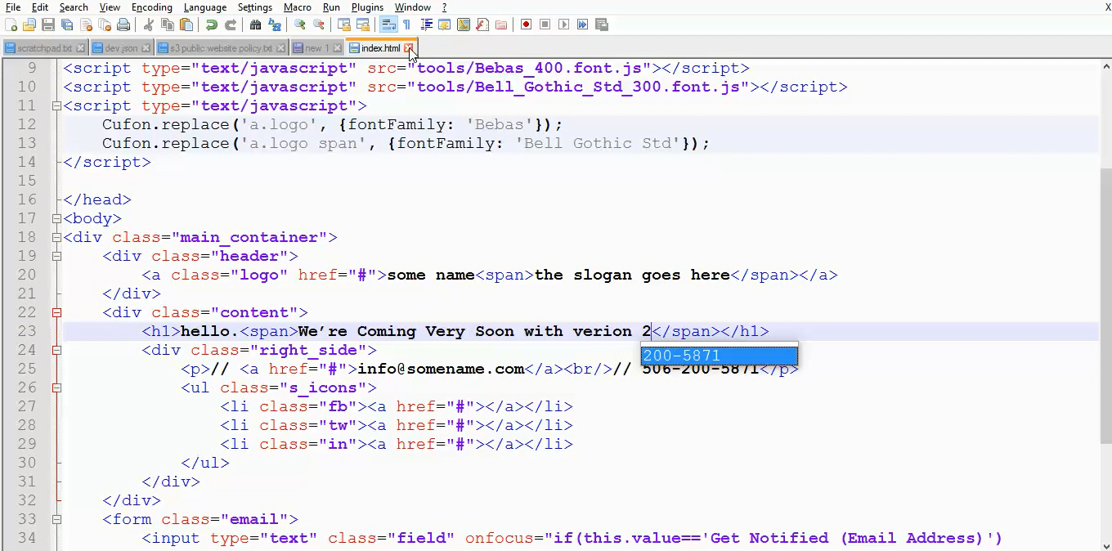

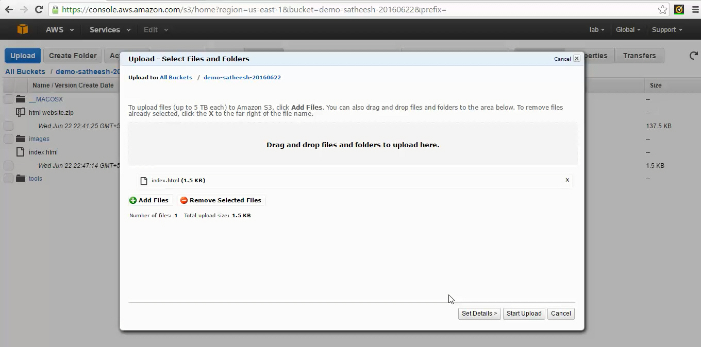

Once you upload the new file you will see a new version under index.html. When versioning is enabled on bucket it keeps the previous versions of the files also with different Version IDs. You can download these old versions also anytime you want to see what was modified.

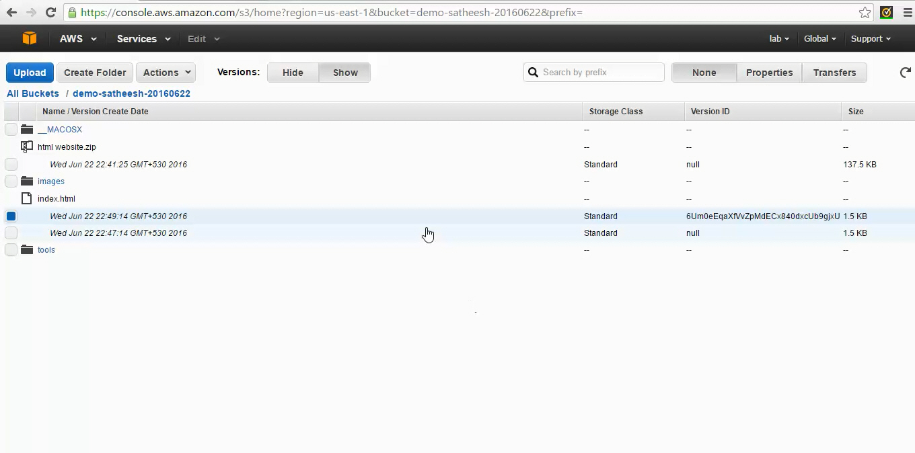

After upload the new index.html go the website URL again and refresh. Now you will see the latest changes on the index page.

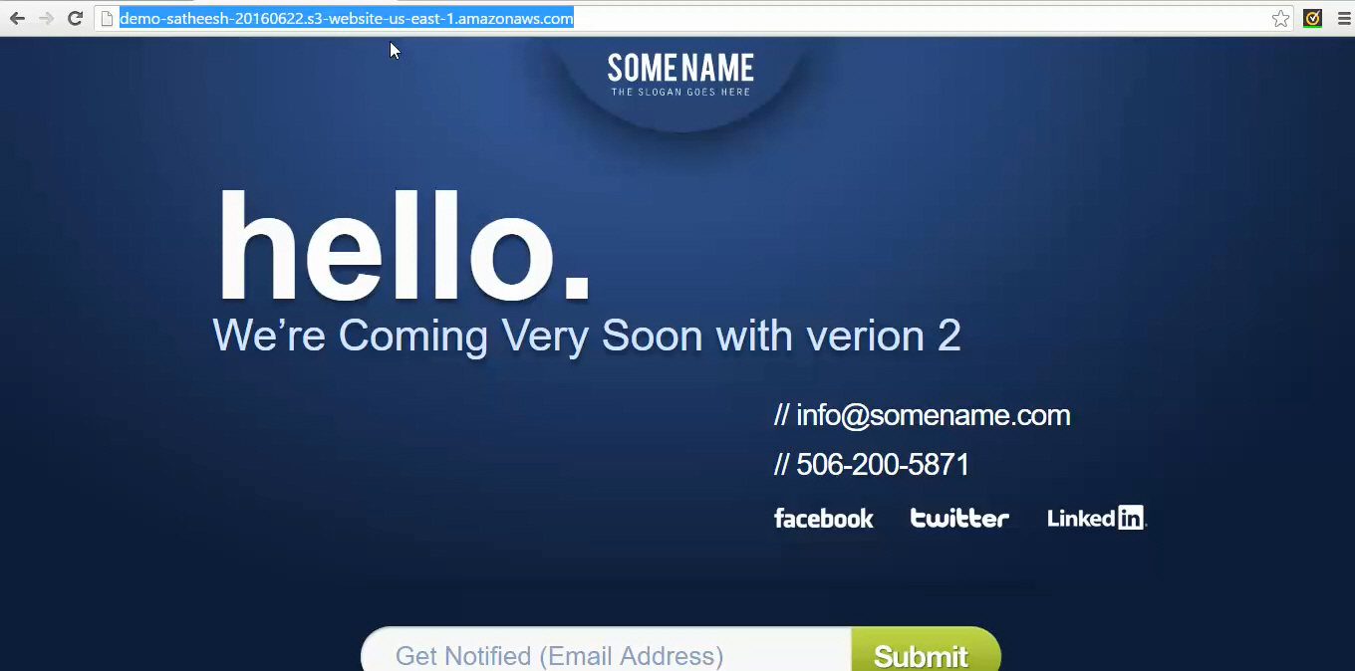

All our web server logs can be redirected to a different s3 bucket. Create a new bucket with name “event-logs-<name>-<yyyymmdd>”

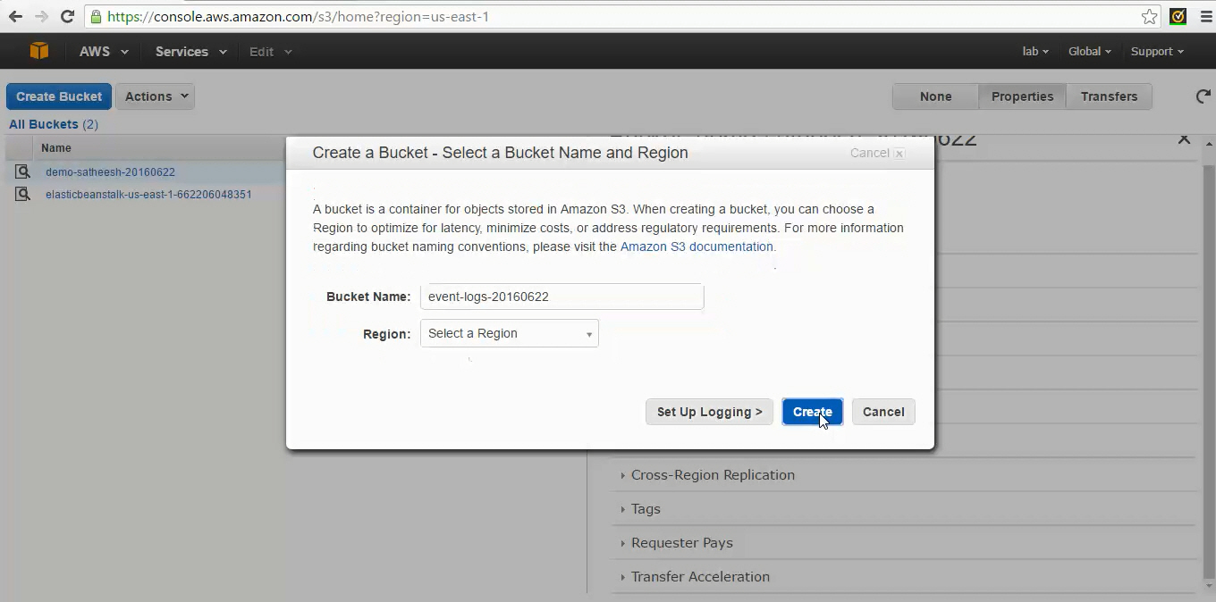

Go to bucket properties and click on “Logging” to enable event logs.

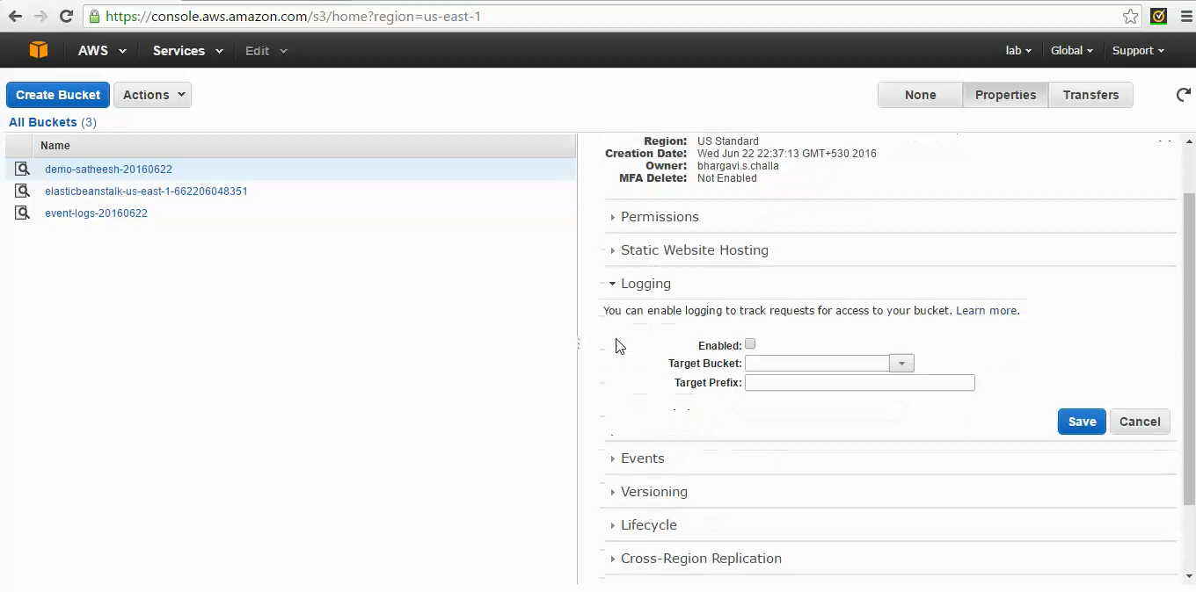

Select the checkbox “Enabled”, select the target bucket from dropdown and click on save.

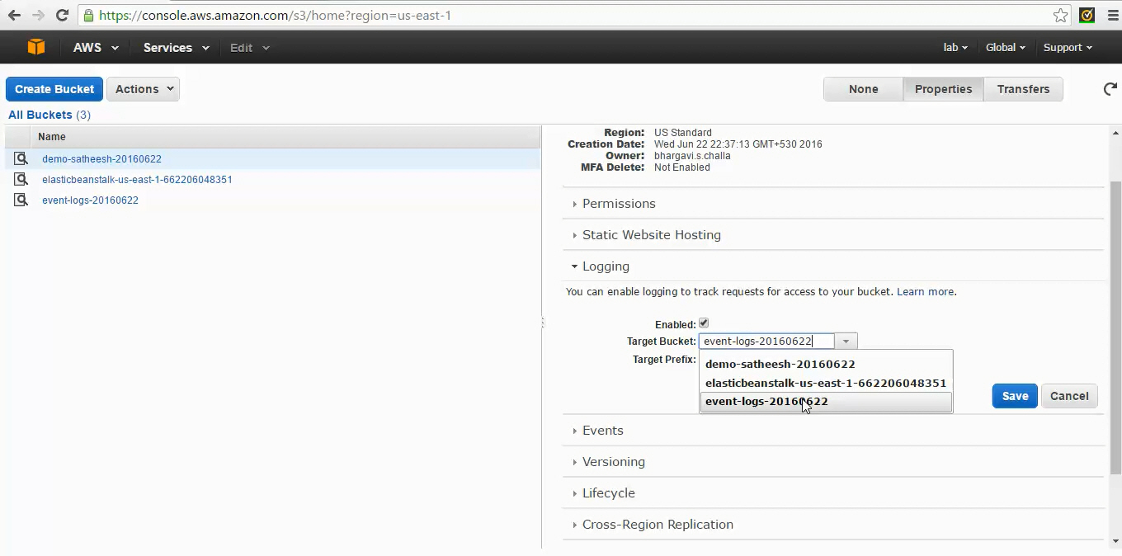

You can go to the bucket created for event logs and check the logs files. Usually this takes some to see the log files in the bucket.

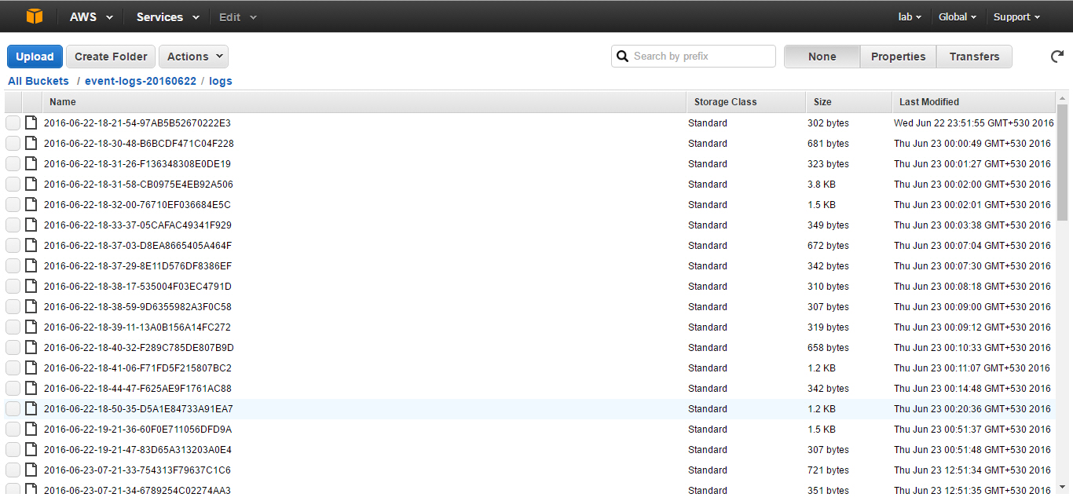

To add archiving policies go to bucket properties and click on “Lifecycle” and click on “Add Rule”. Try this on event logs instead of demo bucket.

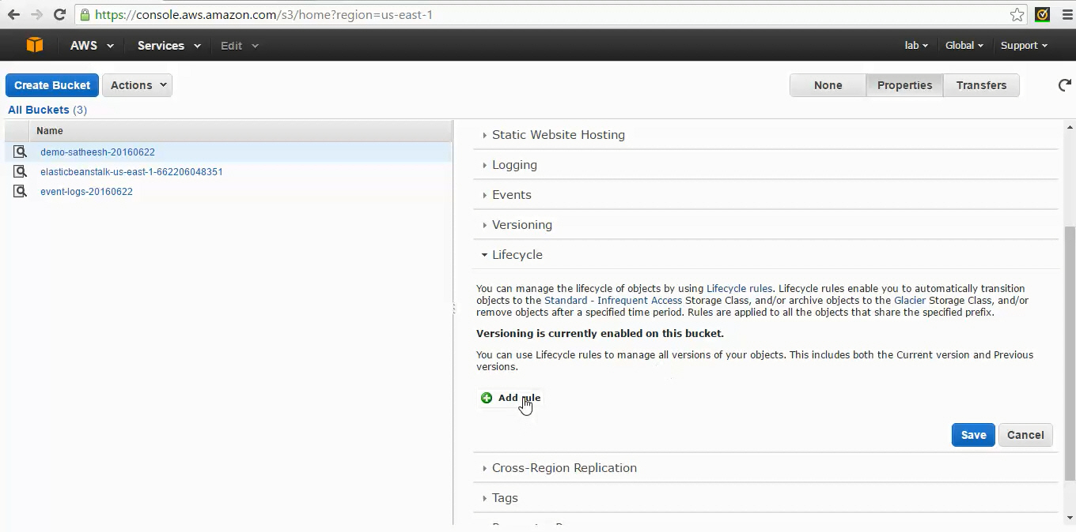

Enter rule name. For example : log-archives-2days-old

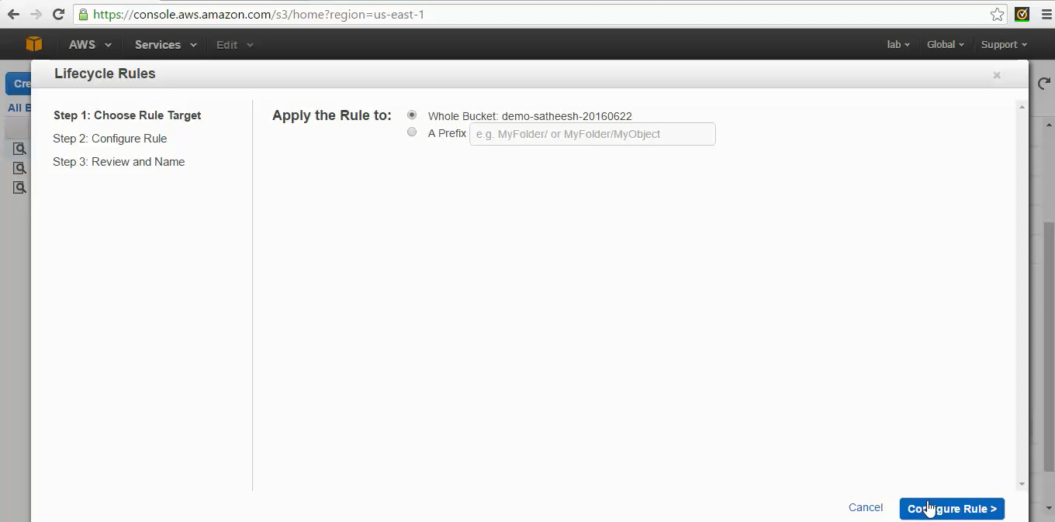

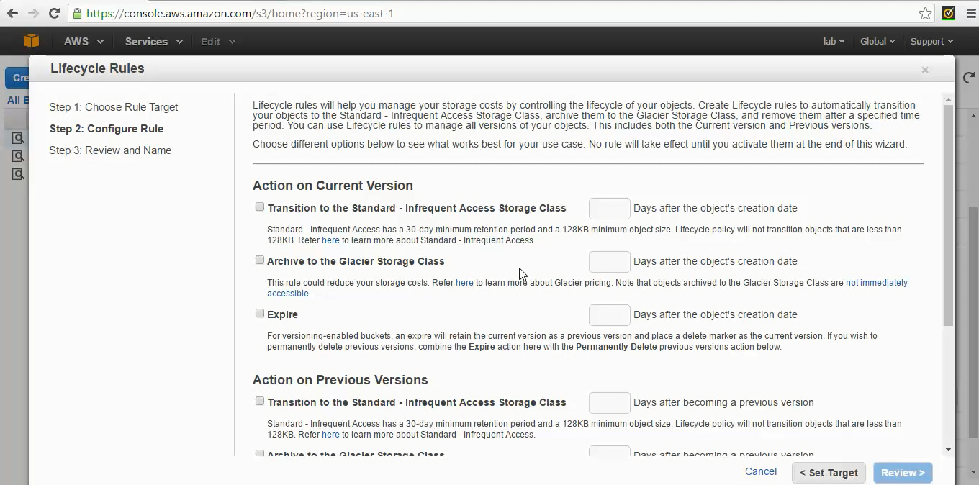

Enable option “Archive to the Glacier Storage Class” and number of days 2. Any files in this bucket older than 2 days will be archived to Glacier. You can also set expire to 5 days which will delete the files from s3 bucket after 5 days.

